Part A — Easy (Items 1–5)
1. Write a query that returns only the `Name` and `Composer` columns from `tracks`, limited to the first 5 rows.

2. Write a query that returns the `FirstName`, `LastName`, and `City` columns from `customers` for rows where `Country` equals 'Germany'.
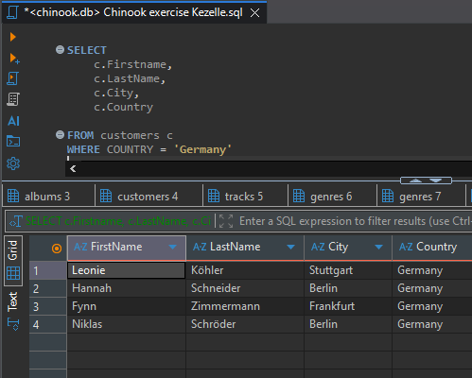
3. Write a query that returns the `Title` column from `albums`, sorted by `Title` in descending alphabetical order, limited to the top 5 rows.

4. Write a query that returns `SupportRepId` and the number of customers assigned to each rep — name the count column `NumCustomers` — sorted by `NumCustomers` in descending order.
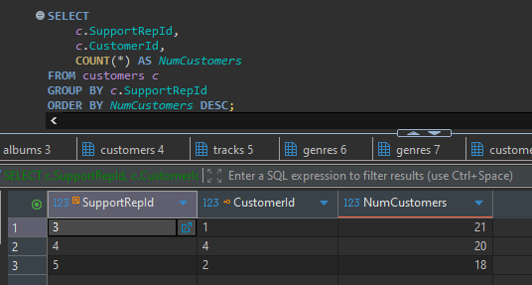
5. Write a query that returns `GenreId` and the average `UnitPrice` of tracks in that genre — name the average column `AvgPrice` — sorted by `AvgPrice` in descending order, limited to the top 5 rows.
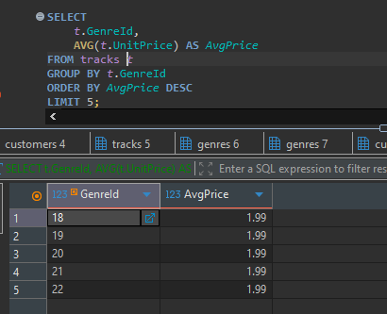
Mistake
SELECT
t.GenreId,
AVE(t.UnitPrice) AS Ave._Unit_Price
FROM tracks t
GROUP BY t.GenreId
- Incorrect Function Name: There is no standard SQL function called AVE(). The correct function for calculating an average is AVG().
- Invalid Column Alias: The alias Ave._Unit_Price contains a period (.). In SQL, a period is a special operator used to separate a table/alias name from a column name (e.g., t.GenreId). The database engine gets confused thinking Ave is a table name.

Part B — Intermediate (Items 6-10)
1. Write a query that returns each genre's `Name` and the number of tracks in that genre — name the count column `NumTracks` — sorted by `NumTracks` in descending order, limited to the top 5 rows.
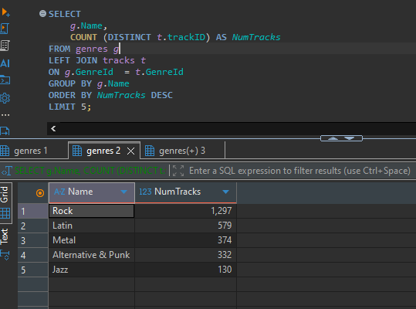
2. Write a query that returns the track name, album title, and artist name for every track — name these columns `TrackName`, `AlbumTitle`, and `ArtistName` respectively — limited to the first 10 rows.
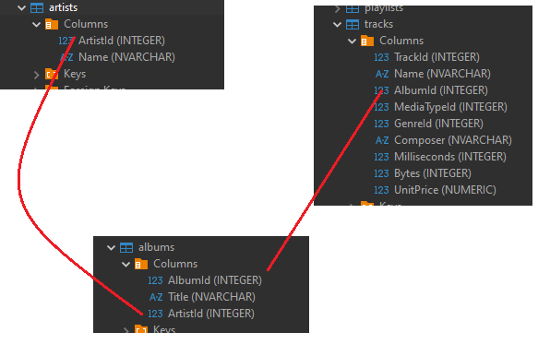

3. Write a query that returns `FirstName`, `LastName`, the track name (named `TrackName`), `Quantity`, and `UnitPrice` from every invoice line ever billed to the customer with `CustomerId = 5`, sorted by `InvoiceLineId` in ascending order.
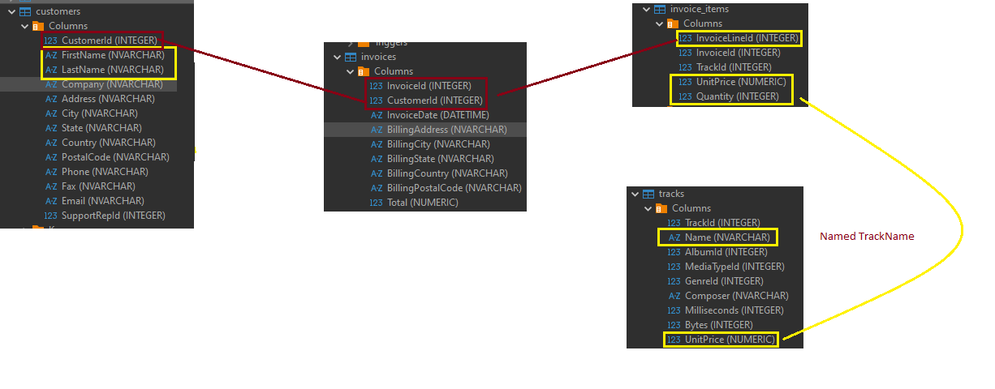
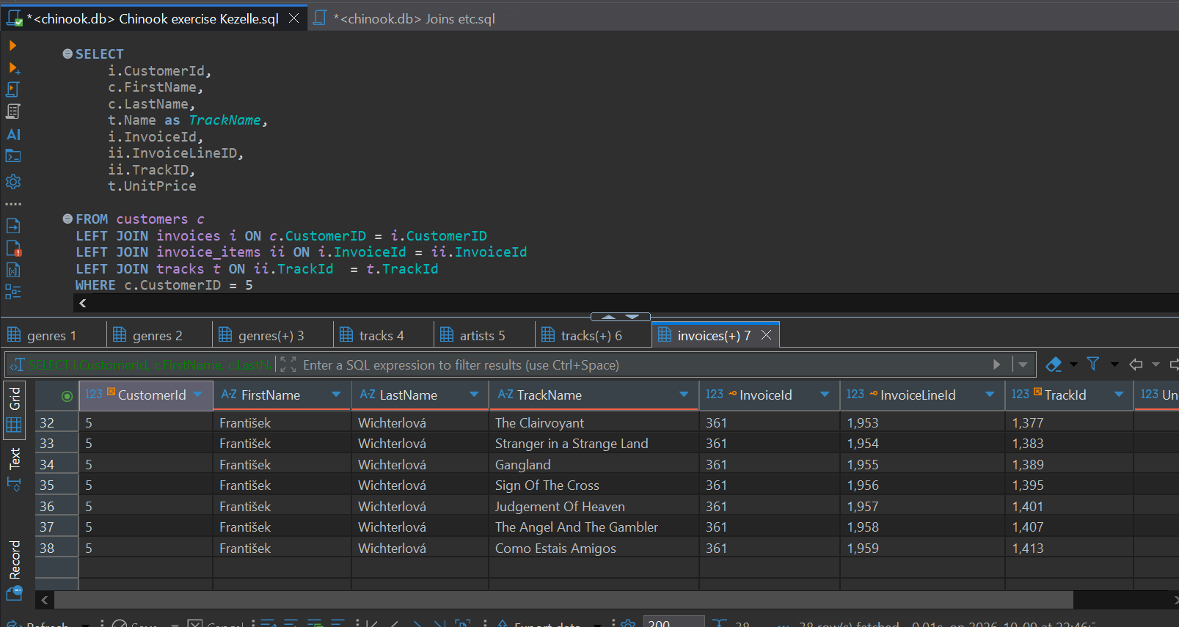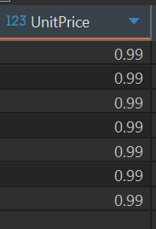
4. Write a query that returns the `Name` of each playlist and the number of tracks it contains — name the count column `NumTracks` — sorted by `NumTracks` in descending order.
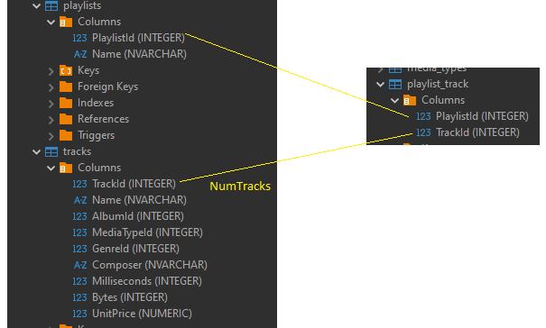

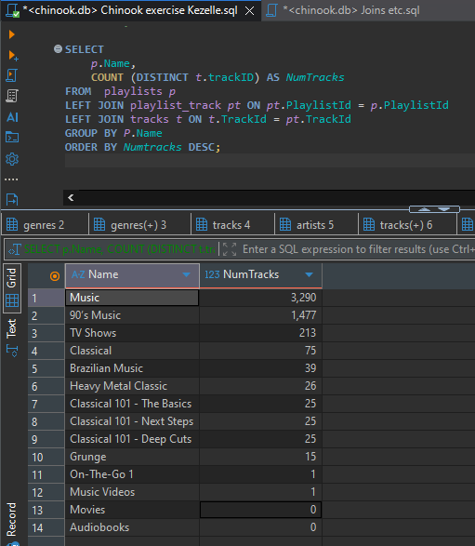
Mistake, the name column in Playlists and Tracks don’t match, hence will yield to zero. I need to map it first using Playlist_track.
5. Write a query that returns `Country` and total revenue generated by customers in that country — computed as `SUM(UnitPrice * Quantity)` from the invoice line items, named `Revenue` — sorted by `Revenue` in descending order, limited to the top 5 rows. 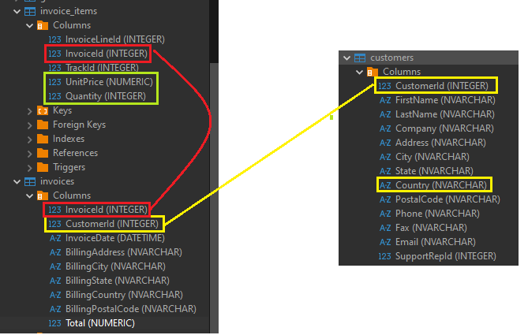
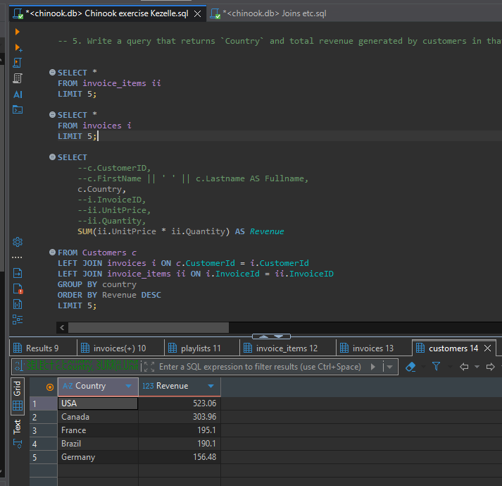

Part C — Advanced (Items 11-15)
1. Using a subquery in the SELECT list (not a JOIN), write a query that returns `FirstName`, `LastName`, and each customer's total amount spent across all their invoices — named `TotalSpent` — sorted by `TotalSpent` in descending order, limited to the top 5 customers.
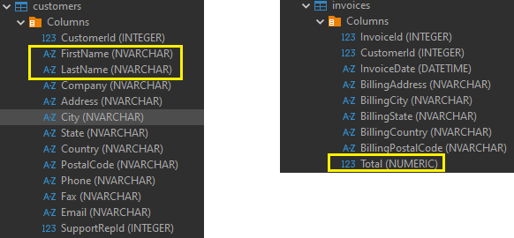
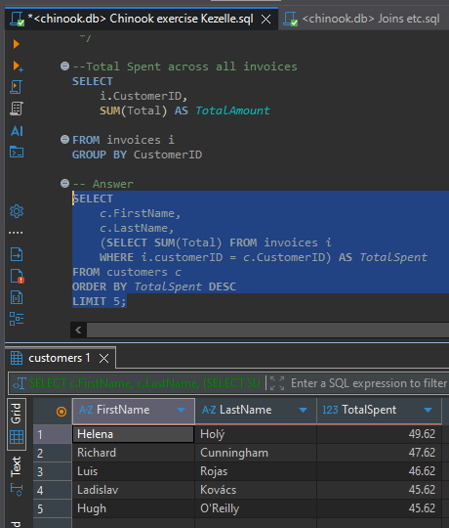
2. Using a subquery in the WHERE clause (not a hardcoded number), write a query that returns the `Name` and `UnitPrice` of every track priced strictly above the average `UnitPrice` across all tracks.
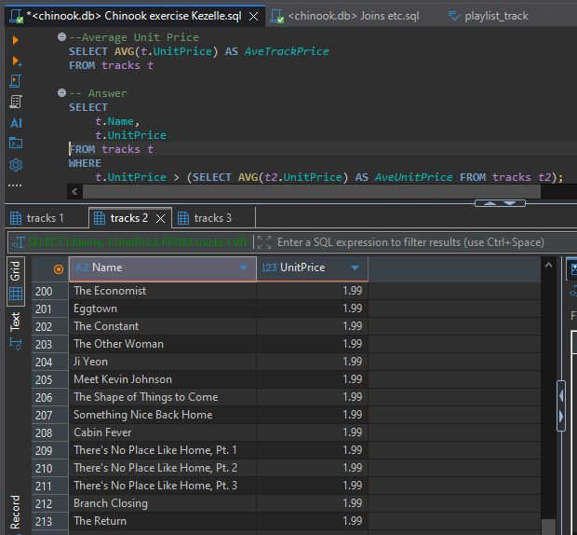

3. Using a CTE (WITH clause), write a query that returns `GenreName` and `Revenue` for the 3 highest-grossing genres, where revenue is `SUM(UnitPrice * Quantity)` from the invoice line items.
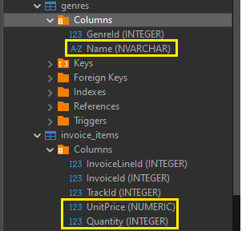

4. Using a NOT IN subquery, write a query that returns the `ArtistId` and `Name` of every artist who has never released an album.
5. Using a CTE that first computes total revenue per customer, write a query that returns `FirstName`, `LastName`, and `Revenue` only for customers whose revenue is greater than the average revenue across all customers, sorted by `Revenue` in descending order.

Mistakes
Putting a blank space in between words.
